|  |  |  |
| --- | --- | --- |
| **Name** | **ID** | **STUDENT SIGN** |
| **Amit Podder** | **20-42273-1** | **Amit** |

**Class Test 04**

1. Normalize the ER Diagram given below up to the 3rd Normal Form and finalize the tables that need to be created. Then (in Oracle using SQL) write down the queries that are required to create all the tables with necessary constraints. Also, insert at least 3 rows of data in each created table.

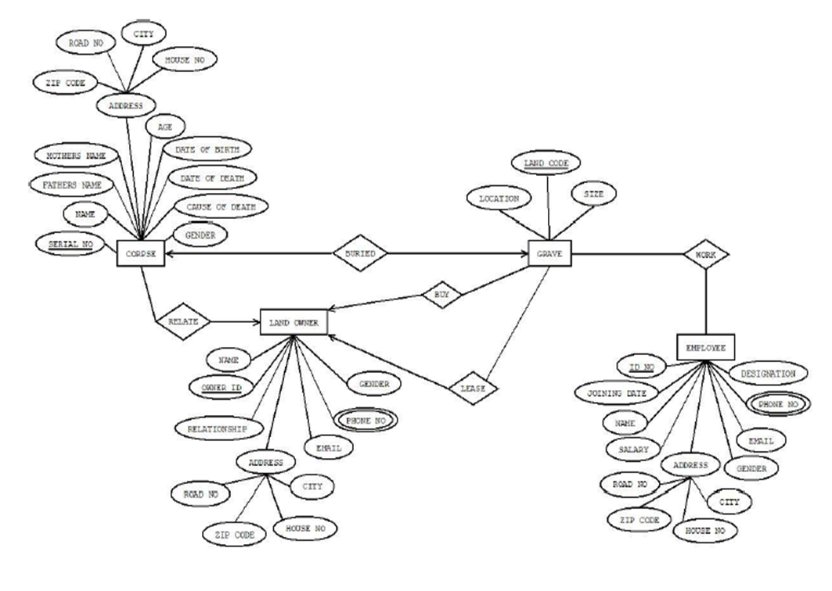

Answer Box (Normalization steps in detail as shown in Normalization Tutorial Slide + all the queries required to create the tables and insert data after Normalization):

**Normalization:**

**Buried:**

(SERIAL NO, NAME, FATHER NAME, MOTHER NAME, ZIP CODE, ROAD NO, CITY, HOUSE NO, AGE, DATE OF BIRTH, date of death, cause of death, gender, location, land code, size.)  
  
1NF: No multivalued attribute  
(serial no, name, father name, mother name, zip code, road no, city, house no, age, date of birth, date of death, cause of death, gender, location, land code, size)  
  
2NF:

1. Serial no, name, father name, mother name, zip code, road no city house no, age, date of birth, date of death, cause of death, gender
2. land code, location, size

3NF:

1. Serial no, name, father name, mother name, age, date of birth, date of death, cause of death, gender
2. A-id, zip code, road no, city, house no
3. land code, location, size

**Work:**

(land code, location, size, Id no, joining date, name, salary, road no, zip code, house no, city, gender, email, phone no, designation)  
  
1NF: Phone is a multivalued attribute   
(land code, location, size, Id no, joining date, name, salary, road no, zip code, house no, city, gender, email, phone no, designation)

2NF:

1. Land code, location, size
2. Id no, joining date, name, salary, road no, zip code, house no, city, gender, email, phone no, designation

3NF:

1. Land code, location, size
2. Id no, joining date, name, salary, gender, email, designation
3. A-id, road no, zip code, house no, city

**Buy:**

(land code, location, size, name, owner id, relationship, road no, zip code, house no, city, email, phone no, gender)

1NF: phone no is a multivalued attribute  
(land code, location, size, name, owner id, relationship, road no, zip code, house no, city, email, phone no, gender)

2NF:

1. land code, location, size
2. owner id, name, relationship, road no, zip code, house no, city, email, phone no, gender

3NF:

1. land code, location, size
2. Owner id, name relationship, email, phone no, gender
3. A-id, road no, zip code, house no, city

**Lease:**

(land code, location, size, name, owner id, relationship, road no, zip code, house no, city, email, phone no, gender)

1NF: phone no is a multivalued attribute   
(land code, location, size, name, owner id, relationship, road no, zip code, house no, city, email, phone no, gender)

2NF:

1. land code, location, size
2. owner id, name, relationship, road no, zip code, house no, city, email, phone no, gender

3NF:

1. land code, location, size
2. Owner id, name relationship, email, phone no, gender
3. A-id, road no, zip code, house no, city

**Relate:**

(serial no, name, father name, mother name, zip code, road no, city, house no, age, date of birth, date of death, cause of death, gender, owner id, name, relationship, road no, zip code, house no, city, email, phone no, gender)

1NF: Phone no is a multivalued attribute  
(serial no, name, father name, mother name, zip code, road no, city, house no, age, date of birth, date of death, cause of death, gender, owner id, name, relationship, road no, zip code, house no, city, email, phone no, gender)  
  
2NF:

1. serial no, name, father name, mother name, zip code, Road no, city, house no, Age, Date of birth, Date of death, Cause of death, gender
2. Owner id, Name, relationship, email, phone no, gender, Zip code, House no, city

3NF:

1. serial no, name, father name, mother name, age, date of birth, date of death, cause of death, gender
2. A-id, zip code, house no, city, road
3. owner id, name, relationship, email

CREATE TABLE Corpse (

serial_no NUMBER PRIMARY KEY,

name VARCHAR2(100),

father_name VARCHAR2(100),

mother_name VARCHAR2(100),

gender VARCHAR2(10),

cause_of_death VARCHAR2(100),

date_of_death DATE,

date_of_birth DATE,

age NUMBER,

zip_code VARCHAR2(10),

road_no VARCHAR2(100),

city VARCHAR2(100),

house_no VARCHAR2(100)

);

INSERT INTO Corpse VALUES (1, 'Pranto Saha', 'Anirudh Saha', 'Arpita Saha', 'Male', 'Natural Causes', TO_DATE('2022-02-02', 'YYYY-MM-DD'), TO_DATE('1970-02-02', 'YYYY-MM-DD'),52, '12345', 'Road 1', 'Dhaka', 'House 01');

INSERT INTO Corpse VALUES (2, 'Tapos Nath', 'Srikanto Nath', 'Anindita Nath', 'Male', 'Heart Attack', TO_DATE('2022-04-04', 'YYYY-MM-DD'), TO_DATE('1980-04-04', 'YYYY-MM-DD'),42, '23456', 'Road 2', 'Barisal', 'House 02');

INSERT INTO Corpse VALUES (3, 'Pulok Sarker', 'Saikot Sarker', 'Chaity Sarker', 'Male', 'Car Accident', TO_DATE('2022-06-10', 'YYYY-MM-DD'), TO_DATE('1960-06-10', 'YYYY-MM-DD'),62, '34567', 'Road 3', 'Chittagong', 'House 03');

CREATE TABLE Employee (

id_no NUMBER PRIMARY KEY,

joining_date DATE,

name VARCHAR2(100),

salary NUMBER,

gender VARCHAR2(10),

email VARCHAR2(100),

phone_no VARCHAR2(20),

designation VARCHAR2(100),

zip_code VARCHAR2(10),

road_no VARCHAR2(100),

city VARCHAR2(100),

house_no VARCHAR2(100)

);

INSERT INTO Employee VALUES (1111, TO_DATE('2020-02-10', 'YYYY-MM-DD'), 'Amit', 50000.00, 'Male', 'amit@gmail.com', '01975675679', 'Manager', '12345', 'Road 1', 'Narayanganj', 'House 01');

INSERT INTO Employee VALUES (2222, TO_DATE('2020-04-20', 'YYYY-MM-DD'), 'Nondon', 30000.00, 'Male', 'nondon@gmail.com', '01721295204', 'Officer', '23456', 'Road 2', 'Narayanganj', 'House 02');

INSERT INTO Employee VALUES (3333, TO_DATE('2020-06-30', 'YYYY-MM-DD'), 'Sudipta', 10000.00, 'Male', 'sudipta@gmail.com', '01762201429', 'Supervisor', '34567', 'Road 3', 'Dhaka', 'House 03');

CREATE TABLE Land_Owner (

owner_id NUMBER PRIMARY KEY,

name VARCHAR2(100),

relationship VARCHAR2(100),

email VARCHAR2(100),

phone_no VARCHAR2(20),

gender VARCHAR2(10),

zip_code VARCHAR2(10),

road_no VARCHAR2(100),

city VARCHAR2(100),

house_no VARCHAR2(100)

);

INSERT INTO Land_Owner VALUES (101, 'Amit', 'Father', 'amit@example.com', '01975675679', 'Male', '12345', 'Road 01', 'Narayanganj', 'House 10');

INSERT INTO Land_Owner VALUES (202, 'Nondon', 'Brother', 'nondon@example.com', '01721295204', 'Male', '23456', 'Road 02', 'Narayanganj', 'House 20');

INSERT INTO Land_Owner VALUES (303, 'Sudipta', 'Uncle', 'sudipta@example.com', '01762201429', 'Male', '34567', 'Road 03', 'Dhaka', 'House 30');

CREATE TABLE Grave (

location VARCHAR2(100),

land_code VARCHAR2(10) PRIMARY KEY,

grave_size VARCHAR2(20)

);

INSERT INTO Grave VALUES ('Cemetery 01', 'C12', '10x10');

INSERT INTO Grave VALUES ('Cemetery 02', 'C14', '8x8');

INSERT INTO Grave VALUES ('Cemetery 03', 'C16', '12x12');